**Moon Lander Design Document**

**Problem Description**

This project. Moon Lander, is a clone of the Lunar Lander that was released by Atari in 1979, and was a precursor to their release of Asterioids game.

The object of the Moon Lander is to safely navigate a lunar module to land on a flat portion of the moon's surface. To pilot the lander, horizontal thrusters can be activated to maneuver the ship left and right, and vertical thrusters can be fired to slow its descent.

**Design Overview**

Describe the major components of your system and how they will interact. This should include a description of the game loop

**Interface Design**

Describe what will show on the screen.

Describe what input the user can provide and what each input command should do.

**Algorithms**

For this section you should think about how inertia should work. In pseudocode, define the way the lander's position should be updated.

**Data-structures**

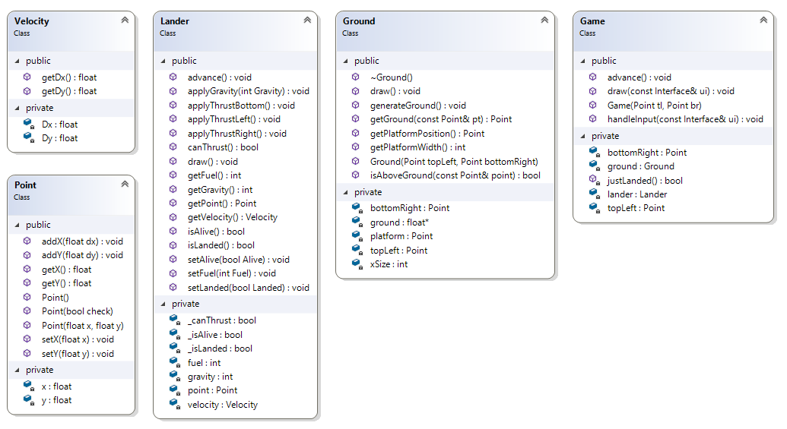

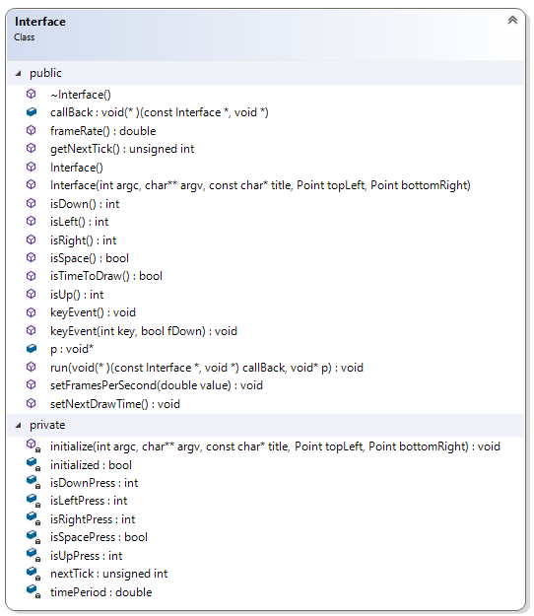

**File Format**

Not Applicable for this project.

**Error Handling**

Identify anything that could go wrong and how your program should react